Da’wah Bot — Conversation Analysis Report
Phase 1: Understanding our users and how the bot performs
Based on 12,448 conversations between the bot and its users.
About this report. We reviewed every conversation the bot has had and measured 13 simple things — who our users are, how engaged they get, what holds them back, and how well the bot performs. Each section explains what we measured and what it means, with the key results shown in a table you can read at a glance. (Percentages are rounded, so a column may not total exactly 100%.)

The big picture
Six findings stand out. Everything after this simply explains them in more detail.
- The bot does most of the talking — and that’s the core problem. In 4 out of 5 conversations the bot dominates, and those conversations have less than half the engagement of balanced ones. Getting the bot to listen more is our single biggest opportunity.
- Most people leave without really engaging. Nearly half of all conversations show no real interaction, and about 6 in 10 users simply disappear partway through.
- More than a third of users are already Muslim. They mostly want religious guidance or help with da’wah — not what this bot was built for. A separate assistant for Muslims could let the main bot focus on non-Muslims.
- The bot is weakest exactly where it matters most. Its main job — introducing Islam to non-Muslims — produces the lowest engagement and among the lowest quality scores of any conversation type.
- We now know what holds people back. The top barriers are rational doubts, plain disinterest, and — for Christians specifically — the Trinity. That is a clear content priority.
- There is real fruit. About 1 in 5 users is a sincere seeker, and roughly 150 conversations ended with someone declaring conversion. The goal is to nurture that minority far better.

The 13 analyses in detail

1. Who is using the bot?
What we looked at. We counted the religious background of everyone who talked to the bot, so our content and effort can match who actually shows up.
What we found. The largest single group is Muslims; among non-Muslims, “Unknown” and Christians lead.
Users by religion
Religion | Conversations | Share
Islam | 4,552 | 36.6%
Unknown | 4,411 | 35.4%
Christianity | 2,036 | 16.4%
Atheism | 671 | 5.4%
Hinduism | 212 | 1.7%
Agnosticism | 161 | 1.3%
Irreligion | 107 | 0.9%
Other | 104 | 0.8%
Buddhism | 103 | 0.8%
Judaism | 88 | 0.7%
Sikhism | 2 | 0.0%

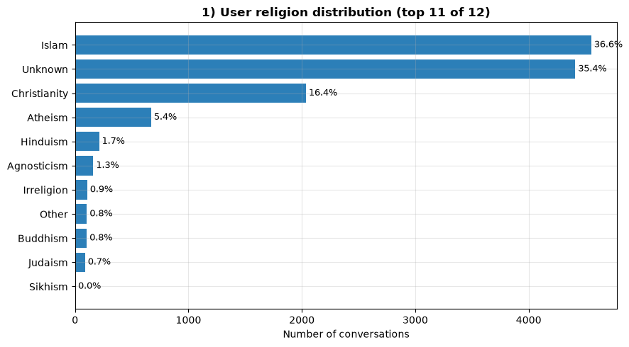
What it means. Two things stand out. First, the bot fails to learn who it’s talking to about a third of the time (the large “Unknown” group) — a missed opportunity, because tailoring the message depends on knowing the person. Second, among people we can identify, Christians are our main audience, so our Christian-focused material carries the most weight.

2. How many users are already Muslim?
What we looked at. We split users into non-Muslims (our conversion audience) and people who are already Muslim, then looked at what the Muslim users came for.
What we found. More than a third are already Muslim, and they come mainly for religious guidance.
Muslim vs non-Muslim users
Audience | Conversations | Share
Non-Muslim | 7,847 | 63.0%
Muslim (already) | 4,601 | 37.0%

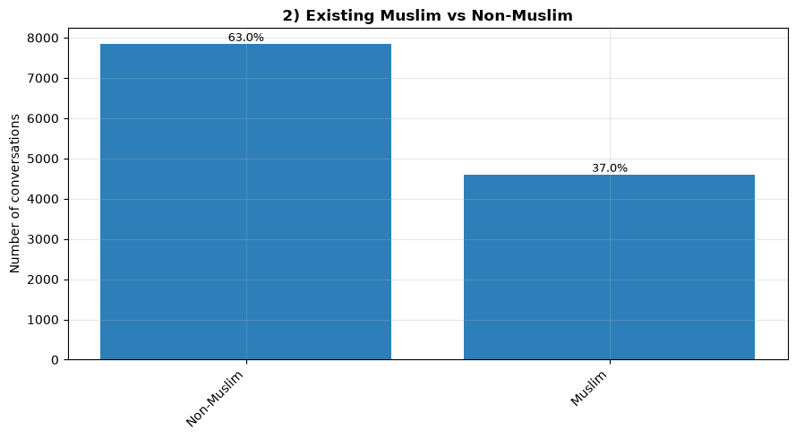

What Muslim users came for (top reasons)
Purpose | Conversations | Share of Muslims
Islamic Guidance | 2,690 | 58.5%
Dawah Training | 838 | 18.2%
Minimal / No Engagement | 537 | 11.7%
Off-Topic | 311 | 6.8%
Content Assistance | 117 | 2.5%

What it means. More than one in three conversations is with someone who isn’t a conversion prospect. They’re using the bot as a religious helper — valuable, but off its core mission. A dedicated assistant for Muslims could serve these needs well and free the main bot to focus on reaching non-Muslims.

3. What languages do people use?
What we looked at. We counted the language each user wrote in, and checked how well the bot performed in each one.
What we found. Arabic and English make up 80% of all conversations; the bot’s quality varies noticeably by language.
Most common languages (top 12 of 60+)
Language | Conversations | Share
Arabic | 5,709 | 45.9%
English | 4,274 | 34.3%
Swahili | 613 | 4.9%
Japanese | 355 | 2.9%
French | 302 | 2.4%
Kurdish | 194 | 1.6%
Tagalog | 158 | 1.3%
Korean | 121 | 1.0%
Spanish | 96 | 0.8%
Urdu | 93 | 0.7%
Chinese | 71 | 0.6%
German | 51 | 0.4%

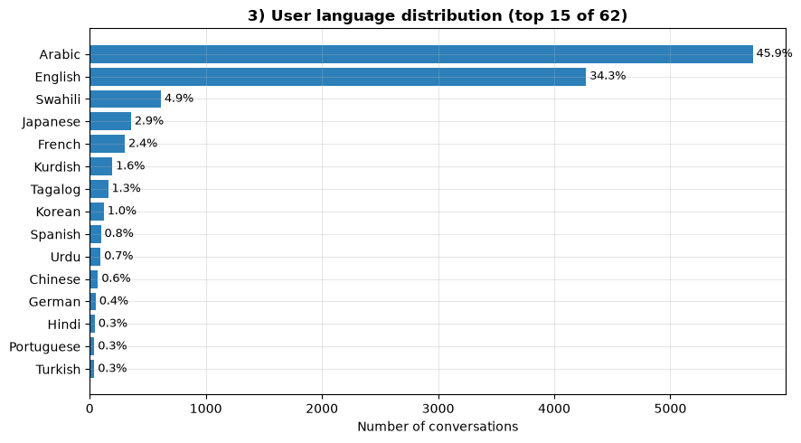

Average quality by language (higher-traffic languages, score out of 5)
Language | Avg quality | Users
Swahili | 3.91 | 613
Korean | 3.52 | 121
Japanese | 3.50 | 355
Arabic | 3.05 | 5,709
French | 2.96 | 302
English | 2.92 | 4,274
Spanish | 2.79 | 96
Kurdish | 2.71 | 194
Chinese | 2.51 | 71

What it means. The bot has surprisingly global reach. But its quality isn’t even. English deserves attention because it’s so common yet only middling, and Chinese and Kurdish trail despite decent numbers. Smaller languages used by only a handful of people are left out here, because their scores rest on too little data to trust yet.

4. What do people use the bot for?
What we looked at. We grouped every conversation by its purpose, and measured how engaged users were in each type.
What we found. Core Da’wah is the most common purpose, but a quarter of traffic never becomes a real conversation — and plain Da’wah engages surprisingly poorly.
Conversations by purpose
Purpose | Conversations | Share
Dawah (core mission) | 3,419 | 27.5%
Minimal / No Engagement | 2,834 | 22.8%
Islamic Guidance | 2,814 | 22.6%
Theological Debate | 1,354 | 10.9%
Dawah Training | 912 | 7.3%
Off-Topic | 783 | 6.3%
Content Assistance | 269 | 2.2%
Emotional Support | 54 | 0.4%
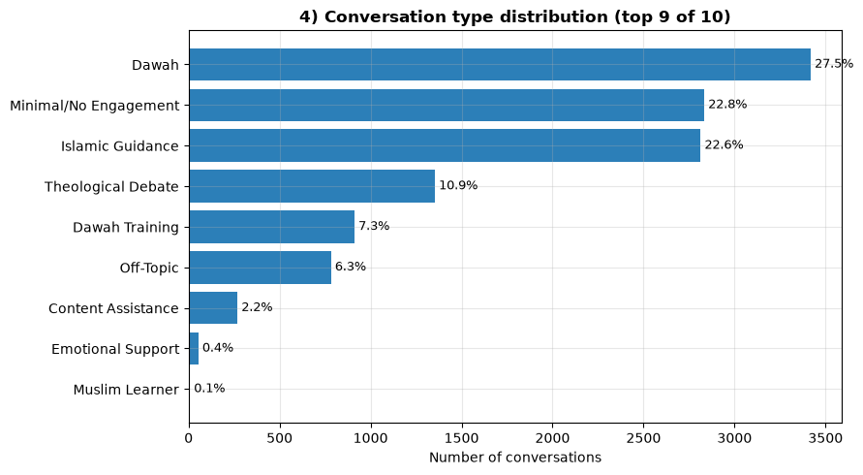

Average engagement by purpose (score out of 5)
Purpose | Avg engagement | Conversations
Theological Debate | 3.68 | 1,354
Dawah Training | 3.35 | 912
Islamic Guidance | 2.81 | 2,814
Emotional Support | 2.63 | 54
Content Assistance | 2.23 | 269
Dawah (core mission) | 2.21 | 3,419
Off-Topic | 1.78 | 783
Minimal / No Engagement | 1.05 | 2,834

What it means. The bot’s flagship activity — introducing Islam — happens a lot but doesn’t hold people well (engagement of just 2.2). The richest conversations come from genuine back-and-forth, in debates and training. And a full quarter of all traffic never becomes a real conversation at all.

5. Are people really engaging?
What we looked at. We scored every conversation from 1 (no real interaction) to 5 (deep back-and-forth). The average was 2.3 and the middle value was 2.
What we found. Nearly half of all conversations show essentially no engagement.
Engagement scores (1 = none, 5 = deep)
Score | Conversations | Share
1 — no real interaction | 5,595 | 44.9%
2 — minimal | 1,752 | 14.1%
3 — reactive | 1,794 | 14.4%
4 — active | 2,379 | 19.1%
5 — deep | 927 | 7.4%

What it means. This is the clearest sign that the bot talks too much. Only about a quarter of conversations reach genuine active or deep engagement (scores 4–5). As the next analysis shows, engagement rises sharply when the conversation is balanced rather than bot-led — so the fix points straight at conversation style.

6. Is the bot dominating conversations?
What we looked at. We measured who did most of the talking in each conversation, and how that related to engagement.
What we found. The bot dominates 4 out of 5 conversations — and balanced conversations engage more than twice as well.
Who leads the conversation
Conversation flow | Conversations | Share
Bot-Dominated | 9,876 | 79.3%
Balanced | 2,373 | 19.1%
User-Dominated | 198 | 1.6%

Average engagement by flow (score out of 5)
Conversation flow | Avg engagement | Conversations
Balanced | 4.26 | 2,373
User-Dominated | 3.38 | 198
Bot-Dominated | 1.81 | 9,876

What it means. This may be the single most important finding in the report. The bot’s habit of lecturing is directly tied to low engagement: balanced conversations score 4.3, bot-dominated ones just 1.8. Encouraging the bot to ask, listen and respond — rather than deliver long scripts — is the biggest lever we have to improve results.

7. What mood are people in when they arrive?
What we looked at. We noted the emotional tone of each user’s first messages, and where the different moods showed up.
What we found. The overwhelming majority arrive calm and neutral — not hostile.
Users’ starting mood (top 8)
Starting mood | Conversations | Share
Neutral | 10,435 | 83.8%
Curious | 606 | 4.9%
Skeptical | 580 | 4.7%
Confident | 166 | 1.3%
Distressed | 154 | 1.2%
Reverent | 136 | 1.1%
Hostile | 126 | 1.0%
Respectful | 61 | 0.5%

What it means. Most people come to the bot open and unthreatening — only 1% arrive hostile, and the skeptical and hostile ones cluster almost entirely in debates. That’s an opportunity: a warm, human, curious opening will suit the typical user far better than a defensive or rigid one. The bot rarely needs to brace for a fight.

8. How do conversations end?
What we looked at. We recorded each user’s state at the end of the conversation — especially whether they simply disappeared.
What we found. Nearly 6 in 10 users vanish before any resolution.
How conversations end (top 9)
Ending | Conversations | Share
Ghosted (disappeared) | 7,391 | 59.4%
Neutral | 1,734 | 13.9%
Satisfied | 880 | 7.1%
Skeptical | 421 | 3.4%
Informed | 403 | 3.2%
Engaged | 391 | 3.1%
Frustrated | 291 | 2.3%
Grateful | 272 | 2.2%
Receptive | 240 | 1.9%

Ghost rate by script-dumping (read with care — see below)
Bot behaviour | Ghost rate
No script dumping | 64.9%
Script dumping | 47.1%

What it means. Most people leave without a resolution — the clearest evidence that the experience loses them partway. The second table looks backwards at first: ghosting appears lower when the bot dumps scripts. This is misleading — many “no script-dumping” conversations are just quick greetings where the bot never got going and the person left at once. So it should not be read as “script-dumping helps.” Analysis 12 shows script-dumping clearly lowers quality.

9. Who are our real prospects?
What we looked at. We classified each user’s underlying intent — sincere seeker, passive listener, debater, troll, and so on.
What we found. Sincere non-Muslim seekers are roughly one in five users.
Users by intent
Intent | Conversations | Share
Passive Listener | 2,798 | 22.5%
Muslim Learner | 2,438 | 19.6%
Genuine Seeker | 2,013 | 16.2%
Greeting Only | 1,925 | 15.5%
Challenger | 1,546 | 12.4%
Off-Topic User | 911 | 7.3%
Troll / Spam | 340 | 2.7%
Conversion Interest | 262 | 2.1%
Dawah Training | 192 | 1.5%

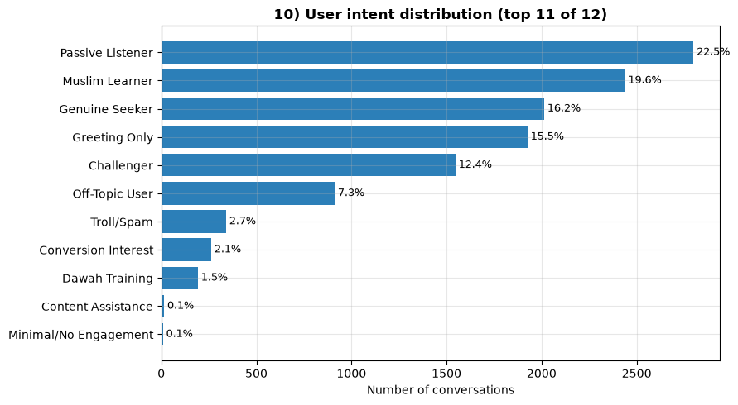
What it means. Our true target audience — genuine seekers plus those showing conversion interest — is about one in five of everyone who shows up. That’s a realistic figure to plan around: the aim isn’t to convert everyone, but to find and nurture that minority. Reassuringly, almost every genuine seeker is a non-Muslim, which confirms the data is behaving sensibly.

10. Where are prospects in their journey?
What we looked at. For non-Muslim da’wah conversations (5,013 in total), we placed each person on a journey from first curiosity to a decision. Shares below are of those 5,013.
What we found. Most prospects are early-stage, but there is real fruit at the end.
Journey stage of non-Muslim prospects
Stage | Conversations | Share
Top — first curiosity | 2,230 | 44.5%
Middle — engaging with arguments | 1,727 | 34.5%
Bottom — near a decision | 102 | 2.0%
Converted — declared conversion | 146 | 2.9%
Dropped — left or lost interest | 807 | 16.1%

What it means. The bot is good at creating awareness and some consideration, but people rarely reach the final decision stage — the gap between “engaging” and “deciding” is where to focus next. Even so, about 150 conversations ended in someone declaring conversion (most often Christians and Hindus). That is real, tangible fruit, well worth studying to learn what worked.

11. How often does the bot “dump scripts”?
What we looked at. We flagged conversations where the bot pasted long, generic pre-written text instead of responding to the person — and compared their quality.
What we found. About one in three conversations involves script-dumping, and those score nearly a full point lower on quality.
How often the bot dumps scripts
Bot behaviour | Conversations | Share
No script dumping | 8,595 | 69.0%
Script dumping | 3,853 | 31.0%

Average quality with vs without script-dumping (score out of 5)
Bot behaviour | Avg quality | Conversations
No script dumping | 3.33 | 8,595
Script dumping | 2.41 | 3,853

What it means. Script-dumping is common and measurably harmful — it drops quality from 3.3 to 2.4. Because it’s easy to spot, it’s also an easy target: reducing it should visibly raise quality, and this number gives us a simple way to track progress over time.

12. How good is the bot overall?
What we looked at. We graded the bot’s handling of each conversation from 1 (broken) to 5 (excellent). The average was 3.0 and the middle value was 3.
What we found. The bot is “adequate” on average, and weakest at its main job.
Bot quality scores (1 = broken, 5 = excellent)
Score | Conversations | Share
1 — broken / irrelevant | 795 | 6.4%
2 — missed the point | 2,909 | 23.4%
3 — adequate but generic | 4,907 | 39.4%
4 — good | 2,600 | 20.9%
5 — excellent | 1,235 | 9.9%

Average quality by purpose (score out of 5)
Purpose | Avg quality | Conversations
Dawah Training | 3.91 | 912
Content Assistance | 3.77 | 269
Islamic Guidance | 3.51 | 2,814
Emotional Support | 3.44 | 54
Theological Debate | 3.07 | 1,354
Off-Topic | 3.04 | 783
Dawah (core mission) | 2.86 | 3,419
Minimal / No Engagement | 2.44 | 2,834

What it means. The bot is competent but rarely exceptional — most conversations land at a middling 3, and only 1 in 10 is excellent. Tellingly, it’s weakest at its main job: core Da’wah scores just 2.9, barely above empty conversations. This echoes the engagement findings — the core Da’wah experience is where improvement would matter most. Lifting the many “3s” toward 4s and 5s is the path to a better bot.

